Chapter 1: Introduction to Robotic Subsystems & Control Loop

Welcome to your first workbook chapter! Before diving into programming your physical VEX robot, we must understand the fundamental software patterns that dictate how a robot processes information and interacts with its environment.

1.1 The Core Paradigms of Robotics
At its core, any autonomous robotic system can be broken down into a repeating operational cycle known as the Sense-Plan-Act paradigm (also widely referred to as the Perception-Planning-Control loop).
[ Perception (Sense) ] ----> [ Planning (Plan) ] ----> [ Control (Act) ^ |_________________ Environment Feedback ______________|
- Perception (Sense): The robot gathers raw data from its environment using physical hardware sensors and processes it into meaningful context.
- Planning (Plan): The robot processes the parsed information, evaluates its mission objectives, and determines what action it should take next.
- Control (Act): The structural hardware signals are sent to the actuators (motors, pistons, etc.) to physically execute the planned action in the real world.

1.2 Control System Foundations
To make a robot move reliably, software engineers utilize two main types of mathematical frameworks:

Open-Loop Control Systems
An open-loop control system computes its input signals using only current state estimations and pre-determined models, without utilizing any live data from sensors to correct its trajectory.
Example: Telling your VEX drivetrain to run its motors at $50\%$ power for exactly 3 seconds. If an obstacle gets in the way or the floor is slippery, the robot will fail to reach its destination because it cannot adjust dynamically.

1.3 Closed-Loop Control Systems
A closed-loop control system constantly measures the active output of the system via sensors and feeds that live state data back into the controller. The system compares the actual state against a desired target state (or setpoint) to calculate an error value.

$$\text{Error}=\text{Setpoint}-\text{Current State}$$

The system then continuously adjusts its actuator power outputs to minimize this error to $0$.

PID Control Fundamentals
The most universally implemented closed-loop methodology in robotics is Proportional-Integral-Derivative (PID) control. While a full PID controller tracks past errors (Integral) and future error trajectories (Derivative), we will begin by isolating the foundational Proportional Control (P-Control) mechanism.
In a basic proportional control loop, the system output (such as motor voltage) is calculated by multiplying the active error by a customizable scaling constant called the proportional gain ($K_{p}$):
$$\text{Output}=K_{p}×\text{Error}$$

If your $K_{p}$ value is tuned poorly, the system might not receive enough power to overcome friction as it nears the goal, resulting in steady-state error—a constant, persistent gap where the robot stalls just short of its intended target.

1.4 Sensors and Actuators

1.5 ActiveCode Exercise: 1D Proportional Control Loop Simulation
Run and modify the Python code block below. This simulates a 1-dimensional robot trying to reach a designated goal position ($x_{\text{goal}}=10.0$).
- Observe what happens with a weak gain ($K_{p}=0.3$).
- Notice how friction causes a steady-state error.
- Try tuning $K_{p}$ higher (e.g., $1.5$ or $2.5$) to see how it alters the robot's ability to settle precisely on the setpoint.
Python
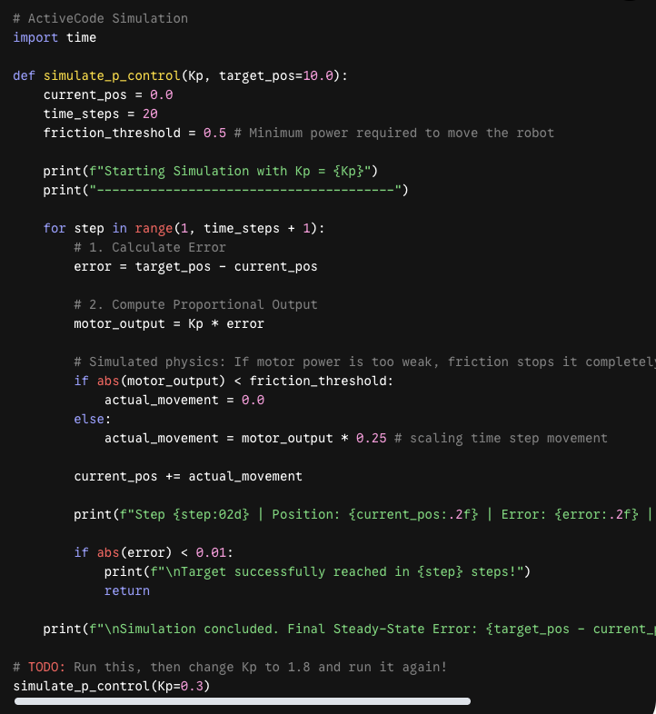

# ActiveCode Simulation
import time

def simulate_p_control(Kp, target_pos=10.0):
current_pos = 0.0
time_steps = 20
friction_threshold = 0.5 # Minimum power required to move the robot

print(f"Starting Simulation with Kp = {Kp}")
print("---------------------------------------")

for step in range(1, time_steps + 1):
# 1. Calculate Error
error = target_pos - current_pos

# 2. Compute Proportional Output
motor_output = Kp * error

# Simulated physics: If motor power is too weak, friction stops it completely
if abs(motor_output) < friction_threshold:
actual_movement = 0.0
else:
actual_movement = motor_output * 0.25 # scaling time step movement

current_pos += actual_movement

print(f"Step {step:02d} | Position: {current_pos:.2f} | Error: {error:.2f} | Motor Power: {motor_output:.2f}")

if abs(error) < 0.01:
print(f"\nTarget successfully reached in {step} steps!")
return

print(f"\nSimulation concluded. Final Steady-State Error: {target_pos - current_pos:.2f}")

# TODO: Run this, then change Kp to 1.8 and run it again!
simulate_p_control(Kp=0.3)

1.4 Conceptual Check
Question:
Imagine you are building your VEX Robot to complete the upcoming sports ball navigation challenge. You mount a front-facing mechanical bumper switch to detect walls and a heavy-duty drivetrain to handle wheel rotation.
Map each hardware element to its correct functional phase inside the standard Perception-Planning-Control loop.
- The bumper switch registering a click sequence when hitting a barrel.
- An if/else statement deciding to turn left because the front bumper is pressed.
- Sending electrical current commands to the left and right wheel motors to execute the spin.
Select the correct structural mapping order:
- (A) Plan $→$ Act $→$ Sense
- (B) Perception $→$ Planning $→$ Control
- (C) Control $→$ Perception $→$ Planning
- (D) Perception $→$ Control $→$ Planning
Check Answer: The correct answer is (B). Reading physical sensor interactions represents Perception, processing conditional behavior logic represents Planning, and driving physical motor systems represents Control.

